Your brain

2.1) Find perimeter difference of earth and circle around it in same units as provided in the example.

$$P_{Circle}-P_{Earth}=X$$

$$2π(r+1) -2πr=X$$

$$2πr+2π -2πr=X$$

$$2π=X$$

2.2) In a survey of 75 software engineers it was found that 46 use open source and 40 use web technologies. Twenty of the software engineers who use open source also use web technologies. Draw Venn diagram for given information.

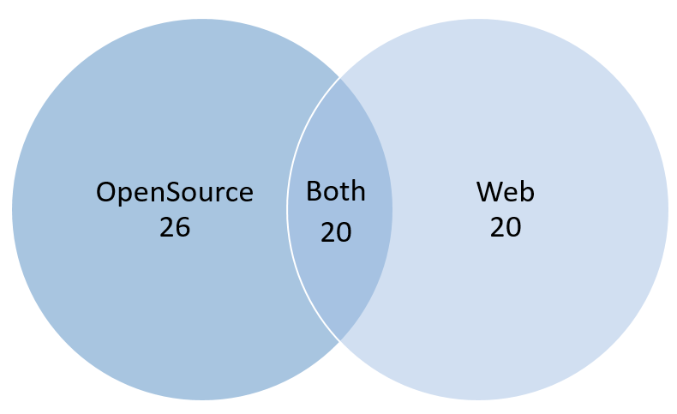

2.3) There are 5 people (Ana, Bob, Charlie, Diana and Ebbe) working with 5 different programming languages distributed through 5 floor building. Each person use a unique language and works in different floor. Please fill in table below from conditions:

* Bob is working with JavaScript;
* Python developer is one floor beneath SQL developer;
* Bob works 3 floors beneath Diana;
* C# developer works on second floor;
* Java developer is 3 floors above Ana;
* Ebbe does not know Python programming language.

|  |  |  |  |  |  |
| --- | --- | --- | --- | --- | --- |
|  | Ana | Bob | Charlie | Diana | Ebbe |
| Language | C# | JavaScript | Python | SQL | Java |
| Floor | 2 | 1 | 3 | 4 | 5 |